**MINI PROJECT REPORT**

**MONUMENTS OF INDIA - A TRAVEL WEBSITE**



Hey how NNN

Submitted By

**Rohit Kumar**

**1900320100131**

**SUBMITTED TO: Mr. ROHIT RASTOGI**

**(Sr. Asst. Professor-CSE)**

**Department of Computer Science & Engineering**

ABES engineering college

GHAZIABAD

**ACKNOWLEDGEMENT**

I would like to express my thanks to the people who have helped me most throughout my project. I am grateful to my teacher **Mr. Rohit Rastogi** for nonstop support for the project.

A special thank of mine goes to my colleague who helped me out in completing the project, where they all exchanged their own interesting ideas, thoughts and made this possible to complete my project with all accurate information. I wish to thank my parents for their personal support or attention who inspired me to go my own way.

At last but not the least I want to thank my friends who treasured me for my hard work and encouraged me and finally to God who made all the things possible for me till the end.

**Dated**: 27 November 2020 **Rohit Kumar**

**B. Tech/CSE/2nd Year/Sec-B**

(i)

**DECLARATION**

I hereby declare that the Report entitled

(“**MONUMENTS OF INDIA - A TRAVEL WEBSITE”)**

is an authentic record of my own work as requirements of Mini Project during the period from 01/Aug/2020 to 05/Nov/2020 for the award of degree of B.Tech. (Computer Science & Engineering), ABES Engineering College, Ghaziabad, under the guidance of Mr. Rohit Rastogi.

**Rohit Kumar**

**1900320100131**

**Date: 05/Aug/2020**

(ii)

**TABLE OF CONTENTS**

**1 List of Figures (iv)**

**2 Abbreviations and Nomenclature (v)**

**3** **CHAPTER 1- Introduction to Project 1-3**

3.1 Basic Introduction

3.2 Problem Description

3.3 Motivation

3.4 Responsive View

3.5 Website Overview

3.6 Site Map

**4** **CHAPTER 2- Survey 4**

**5** **CHAPTER 3- Tools & Technology Used 5-25**

5.1 HTML

5.2 CSS

5.3 JavaScript

5.4 Sample HTML Code

5.5 Sample CSS Code

5.6 Some Sample Important Codes

**6** **CHAPTER 4- Snapshots 26-31**

6.1 Monuments of India (monuments.html)

6.2 Taj Mahal (tajmahal.html)

6.3 Red Fort (redfort.html)

6.4 Lotus Temple (lotustemple.html)

6.5 Qutub Minar (qutubminar.html)

6.6 About Us (about.html)

**7** **CHAPTER 5- Result and Discussions 32-34**

7.1 Introduction

7.2 SSL Certificate

7.3 Cookies

**8 CHAPTER 6- Conclusions and Future Scope 35**

**9** **References 36**

(iii)

**LIST OF FIGURES**

|  |  |
| --- | --- |
| NO. | FIGURE CAPTION |
| 1 | Responsive View |
| 2 | Website Overview |
| 3 | Tourism Influencing Countries |
| 4 | HTML Icon |
| 5 | CSS Icon |
| 6 | JavaScript Icon |
| 7 | Embed YouTube Video |
| 8 | Embed Google Maps Location |
| 9 | Embed Maps 3D View |
| 10 | Visitor Count |
| 11 | Marquee Behavior |
| 12 | Contact Link |
| 13 | Output for Monuments of India (monuments.html) |
| 14 | Output for Taj Mahal (tajmahal.html) |
| 15 | Output for Red Fort (redfort.html) |
| 16 | Output for Lotus temple (lotustemple.html) |
| 17 | Output for Qutub Minar (qutubminar.html) |
| 18 | Output for About Us (about.html) |
| 19 | Image of Website SSL Certificate - General |
| 20 | Image of Website SSL Certificate - Details |
| 21 | Image of Website SSL Certificate – Certification Path |
| 22 | Cookies Used by Website |
| 23 | Methodology Used |

(iv)

**ABBREVIATIONS AND NOMENCLATURE**

**ABBREVIATIONS**

1.CSE - Computer Science and Engineering

2.HTML - Hyper Text Markup Language

3.CSS - Cascading Styles Sheet

4.CST - Chhatrapati Shivaji Terminus

5.SSL - Secure Sockets Layer

(v)

**CHAPTER 1 - INTRODUCTION TO PROJECT**

The Project Named as Monuments of India – A Travel Site is a webbased Project (Website) that provides information about Some famous monuments of India.

**1.BASIC INTRODUCTION:**

This project consists of 12 webpages that are linked together to form a website (i.e <https://rebrand.ly/monumentsofindia>).

The webpages are described as:

1.Monuments of India  
2.Taj Mahal   
3.Red Fort   
4.Lotus Temple   
5.Qutub Minar   
6.Victoria Memorial   
7.Gateway of India   
8.Charminar   
9.Hawa Mahal   
10.Mysore Palace   
11.CST   
12.About Us

This project provides basic information about these:

1.Details

2.Gallery

3.3D view

4.Maps

5.Video

6.Other Basic Details.

**2.PROBLEM DESCRIPTION:**

* In these busy times people are busy in their work like using (like smartphone professional work).They have no free time to go over the beauty of India.
* Peoples go through Malls , Cinema halls to spend their Valuable time and to feel happy.
* As the future arises people will forget about monuments.

This Website will Guide/Motivate these people to go through the real beauty of India.

**3.MOTIVATION**

The thing which Motivate me to build this Website are:

* The decrement of People excitement towards traveling.
* Decreasing Number of Tourists.
* To Reduce the Impact of COVID-19 on Tourism

**4. RESPONSIVE VIEW**

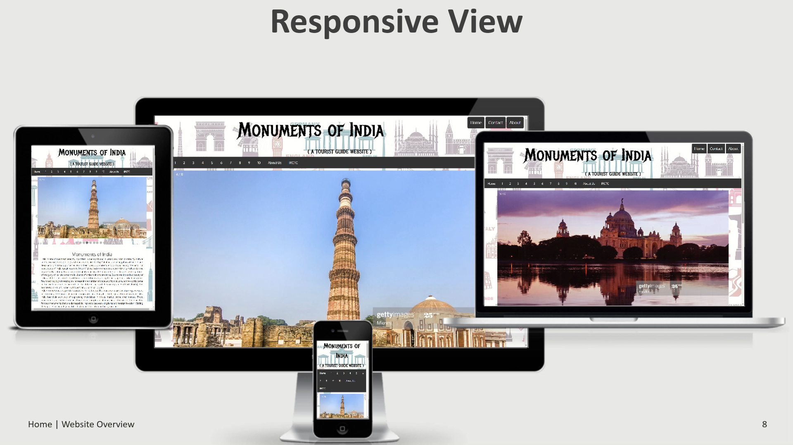

**Figure 1.** Responsive View

2

**5.WEBSITE OVERVIEW**

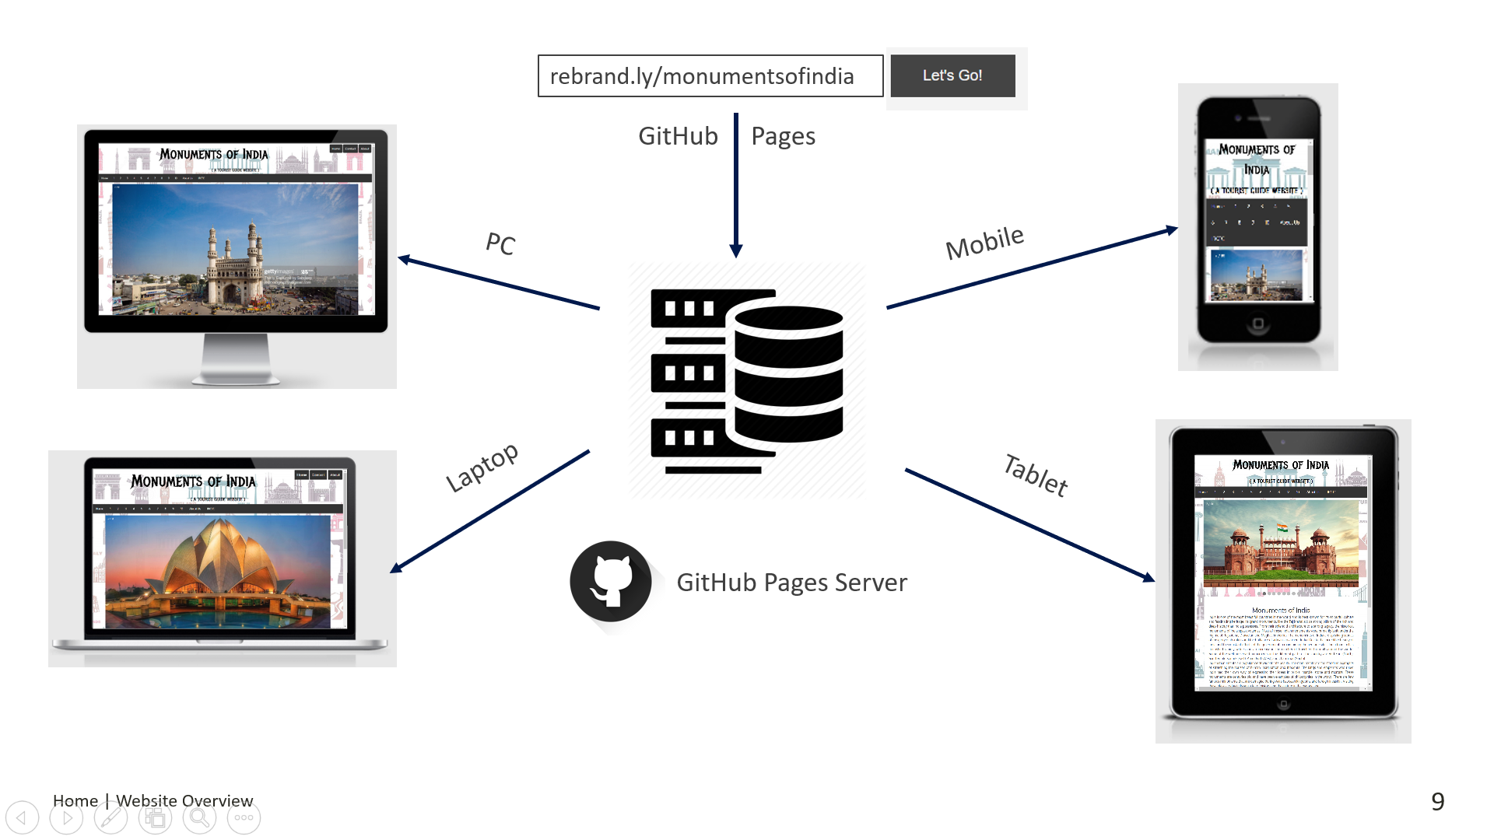

**Figure 2.** Website Overview

**6.SITE MAP**

**HOME (monuments.html)**

**Information**

**Gallery**

**Maps**

**Video**

**3D View**

**User Count**

**1.Taj Mahal   
2.Red Fort   
3.Lotus Temple   
4.Qutub Minar   
5.Victoria Memorial   
6.Gateway of India   
7.Charminar   
8.Hawa Mahal   
9.Mysore Palace   
10.CST**

**ABOUT Us (about.html)**

3

**CHAPTER 2 – SURVEY**

As per the survey of World Travel and Tourism Council, India is among the top 15 countries in the world in which the Tourism takes a Part in Country Economy.

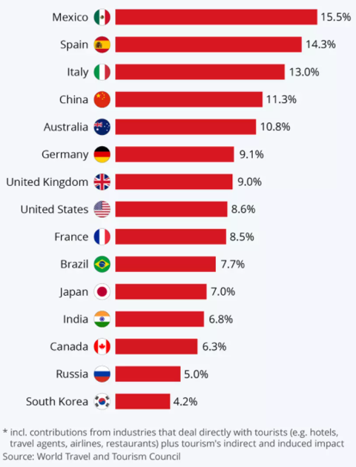

**Figure 3.** Tourism Influencing Countries

But Tourism Sector is highly influenced by COVID-19.The leads to the some loss of India Economy.

**CHAPTER 3 - TOOLS & TECHNOLOGY USED**

This Project **“Monuments of India – A Travel Website”** is a website that can be created using various languages like:

**1.HTML (Hyper Text Markup Language)**

* HTML is a highly used language to create a Webpages.
* HTML defines the structure of a HTML webpage.
* HTML defines how the content are placed in a Webpage
* It links CSS files & JavaScript to webpages
* It helps in linking External pages to a website.
* All content will be available in a website using HTML Code.



**Figure 4.** HTML Icon

**2.CSS (Cascading Styles Sheet)**

* CSS stands for Cascading Style Sheets
* CSS describes how HTML elements are to be displayed on screen, paper, or in other media
* CSS saves a lot of work. It can control the layout of multiple web pages all at once
* External stylesheets are stored in CSS files.



**Figure 5.** CSS Icon

6

**3.JavaScript**

* It is a Dynamic programming Language.
* JavaScript is a lightweight, interpreted programming language.
* Designed for creating network-centric applications.
* Complementary to and integrated with Java.
* Complementary to and integrated with HTML.
* Open and cross-platform



**Figure 6.** JavaScript Icon

7

**4.SAMPLE HTML CODES**

<! –– HTML CODING FOR MONUMENTS (monuments.html) ––>

<!doctype html>

<html lang="en">

<head>

<style>

body {

background:transparent url('background-img/A.jpg') repeat center top;

}

</style>

<title>Home | Monuments of India</title>

<meta charset="utf-8">

<meta http-equiv="X-UA-Compatible" content="IE=edge">

<meta name="viewport" content="width=device-width, initial-scale=1">

<link rel="stylesheet" href="css/bootstrap.min.css">

<link rel="stylesheet" href="https://cdnjs.cloudflare.com/ajax/libs/font-awesome/4.7.0/css/font-awesome.min.css">

<link rel="stylesheet" href="https://maxcdn.bootstrapcdn.com/bootstrap/3.3.7/css/bootstrap.min.css">

<link rel="stylesheet" href="https://maxcdn.bootstrapcdn.com/bootstrap/3.3.7/css/bootstrap.min.css">

<link rel="stylesheet" href="css/style.css">

<link href="https://fonts.googleapis.com/css2?family=Metal+Mania&display=swap" rel="stylesheet">

<link href="https://fonts.googleapis.com/css2?family=Oxygen&display=swap" rel="stylesheet">

<link rel="icon" href="background-img/A.png" sizes="40x40">

</head>

<body>

<! –– HEADER ––>

<div class="header">

<div class="header-name" id="head-name">Monuments of India

<div class="header-button">

<a class="active" href="monuments.html">Home</a>

<a class="active" href="https://rebrand.ly/rk/website" target="_blank" >Contact</a>

<a class="active" href="about.html">About</a>

</div>

<h3>( A TRAVEL WEBSITE )</h3></div</div>

<! –– MENU BAR ––>

<div>

<ul class="links">

<li><a href="monuments.html" title="Monuments of India" >Home</a></li>

<li><a href="tajmahal.html" title="Taj Mahal" >1</a></li>

<li><a href="redfort.html" title="Red Fort" >2</a></li>

<li><a href="lotustemple.html" title="Lotus Temple" >3</a></li>

<li><a href="qutubminar.html" title="Qutub Minar" >4</a></li>

<li><a href="victoriamemorial.html" title="Victoria Memorial" >5</a></li>

8

<li><a href="gatewayofindia.html" title="Gateway of India" >6</a></li>

<li><a href="charminar.html" title="Charminar" >7</a></li>

<li><a href="hawamahal.html" title="Hawa Mahal" >8</a></li>

<li><a href="mysorepalace.html" title="Mysore Palace" >9</a></li>

<li><a href="cst.html" title="CST" >10</a></li>

<li><a href="about.html" title="About Us" >About Us</a></li>

<li><a href="https://www.irctc.co.in/nget/train-search" target="_blank" title="Visit Website of IRCTC eTicketing System" >IRCTC</a></li>

<li><a href="https://www.oyorooms.com/" target="_blank" title="Visit Website of OYO Rooms" >OYO Rooms</a></li>

<li><a href="https://www.yatra.com/" target="_blank" title="Visit Website of Yatra" >Yatra</a></li>

</ul>

</div>

<! –– TOP BUTTON ––>

<button onclick="topFunction()" id="myBtn" title="Go to top">^</button>

<script>

var mybutton = document.getElementById("myBtn");

window.onscroll = function() {scrollFunction()};

function scrollFunction() {

if (document.body.scrollTop > 20 || document.documentElement.scrollTop > 20) {

mybutton.style.display = "block";

}

else {

mybutton.style.display = "none";

}

}

function topFunction() {

document.body.scrollTop = 0;

document.documentElement.scrollTop = 0;

}

</script>

<! –– IMAGE SLIDESHOW ––>

<div class="slideshow-container">

<div class="mySlides fade">

<div class="numbertext">1 / 10</div>

<img src="1.tajmahal/image1.jpg" style="width:100%">

</div>

<div class="mySlides fade">

<div class="numbertext">2 / 10</div>

<img src="2.redfort/image1.jpg" style="width:100%">

</div>

<div class="mySlides fade">

<div class="numbertext">3 / 10</div>

<img src="3.lotustemple/image1.jpg" style="width:100%">

</div>

<div class="mySlides fade">

<div class="numbertext">4 / 10</div>

<img src="4.qutubminar/image1.jpg" style="width:100%">

9

</div>

<div class="mySlides fade">

<div class="numbertext">5 / 10</div>

<img src="5.victoriamemorial/image1.jpg" style="width:100%">

</div>

<div class="mySlides fade">

<div class="numbertext">6 / 10</div>

<img src="6.gatewayofindia/image1.jpg" style="width:100%">

</div>

<div class="mySlides fade">

<div class="numbertext">7 / 10</div>

<img src="7.charminar/image1.jpg" style="width:100%">

</div>

<div class="mySlides fade">

<div class="numbertext">8 / 10</div>

<img src="8.hawamahal/image1.jpg" style="width:100%">

</div>

<div class="mySlides fade">

<div class="numbertext">9 / 10</div>

<img src="9.mysorepalace/image1.jpg" style="width:100%">

</div>

<div class="mySlides fade">

<div class="numbertext">10 / 10</div>

<img src="10.cst/image1.jpg" style="width:100%">

</div>

</div><br>

<div style="text-align:center">

<span class="dot"></span> <span class="dot"></span> <span class="dot"></span><span class="dot"></span>

<span class="dot"></span> <span class="dot"></span><span class="dot"></span> <span class="dot"></span>

<span class="dot"></span><span class="dot"></span>

</div>

<script>

var slideIndex = 0;

showSlides();

function showSlides() {

var i;

var slides = document.getElementsByClassName("mySlides");

var dots = document.getElementsByClassName("dot");

for (i = 0; i < slides.length; i++) {

slides[i].style.display = "none";

}

slideIndex++;

if (slideIndex > slides.length) {slideIndex = 1}

for (i = 0; i < dots.length; i++) {

dots[i].className = dots[i].className.replace(" active", "");

}

slides[slideIndex-1].style.display = "block";

dots[slideIndex-1].className += " active";

setTimeout(showSlides, 1000);

10

}

</script>

<! –– BODY ––>

<div id="body-text"><div class="body-title">Monuments of India</div>India is one of the most beautiful countries in the world and is best known for its colourful culture and fascinating heritage. Its grand monuments, like the Taj Mahal act as strong pillars of the rich and deep history that India possesses. From their splendid architecture to a strong legacy, the historical monuments of India speak volumes. Most of these Indian monuments were primarily built under the regime of Rajputana, Dravidian and Mughal emperors. The monuments of India are speaking stones of the glory of its rulers and the brilliance of artisans in ancient India. Due to the incredible beauty of India and the constant efforts of the government in maintaining the heritage sites, India tourism has flourished rapidly witnessing an increase in the number of travellers from all around the world. Some of the well-preserved monuments in the different parts of the country are Red Fort (North), Sun Temple Konark (East), Amer Fort (West) and Charminar (South).<br>Indian monuments are popular worldwide for its beauty. The monuments are the standing examples of stretching the horizon of human imagination and thoughts. The kings and emperors who ruled India had their own way of expressing their ideas in bricks, marble, stone and mortars. These monuments are centuries old and have been examples of philosophies in the world. There are few famous monuments that are damaged during wars between kingdoms and foreign invasion. Visiting these places today tells you a lot of history and the culture in the bygone age.</div>

<div id="body-text"><div class="body-title">Historical Places in India</div>The ancient monuments of India are globally popular for their architectural brilliance. And, the marble inlay and stone carving work displayed through these centuries-old monuments is incomparable. So, if you’re looking for holidays in India then plan a tour of historical places in India. In the state of Rajasthan, the monuments narrate the tales of strength, romance and bravery. While visiting these masterpieces, one can feel the aura and power of the ancient Indian rulers. <br>Also, tourists will get to know that religion plays a significant role in Indian culture. And, the diversity of religions is clearly evident in the historical monuments too. <br>The prominent cities of India as Mumbai, Delhi and Agra also have a lot to offer history lovers. With wonderful Mughal architecture dipped in the essence of Islam, the charm of Delhi never fades in terms of enticing the travellers. India Gate, Jama Masjid, Pura Qila, Lodi Tomb and Jantar Mantar are some of the most famous monuments in Delhi. <br>The list of well-known monuments in Agra includes Agra Fort, Mariam's Tomb, Panch Mahal and Marium-uz-Zamani Palace and the Taj Mahal - one of the seven wonders of the world. Some key heritage monuments in Mumbai are Elephanta Caves, Gateway of India and Chhatrapati Shivaji Terminus.</div>

<div id="body-text"><div class="body-title">Famous Monuments of India</div>If you are a history buff, monuments like Mysore Palace, Sanchi Stupa, Fatehpur Sikri and Hawa Mahal should feature on your must-visit monuments in India. Situated in the Mysore city of Karnataka, Mysore Palace is a royal residence of Wadiyar dynasty. The great Sanchi Stupa in Bhopal is among the most striking Buddhist monuments in India. <br>Built during the Mauryan period it reflects a perfect blend of Buddhist art and architecture. The sprawling Fatehpur Sikri complex was built by the Mughal emperor, Akbar, in the 16th century. With the UNESCO world heritage site status, the architecture of Fatehpur Sikri showcases a perfect amalgamation of Persian and Hindu architecture. Hawa Mahal, located in the heart of Pink City, Jaipur, is a unique honeycomb structure said to reflect the royalty of Rajput ruler, Maharaja Sawai Pratap Singh.</div>

11

<div id="body-text"><div class="body-title">National Monuments of India</div>Among the most popular national monuments of India are the Red Fort, Taj Mahal, Qutub Minar, Humayun's Tomb, Sun Temple Konark and Hampi. Built in the 16th century, the Red Fort in Delhi is known to transport the visitors back to the era of Mughal dynasty. <br>The icon of immortal love – The Taj Mahal, a white-marbled marvel, situated on the banks of River Yamuna in the city of Agra, never fails to mesmerize. Also, Humayun's Tomb of Delhi is considered as the finest example of Persian architecture. Further, Odisha’s Konark Sun Temple, which is constructed in the shape of a colossal chariot, is a UNESCO world heritage site. Once known as the capital of the Vijayanagar Empire, Hampi is the most popular tourist attraction in Karnataka. Constructed in the14th century, its ruins are now a UNESCO world heritage site. Undoubtedly, Indian monuments are the pride of the nation!<br><br>Check Out the links for more details given below:</div>

<hr width="100%">

<ul class="reference container-fluid">

<li><div class="youtube col-xs-1 col-sm-1 col-md-3 col-lg-3"><iframe src="https://www.youtube.com/embed/b9STkhzN9qM" frameborder="0" allow="accelerometer; autoplay; clipboard-write; encrypted-media; gyroscope; picture-in-picture" allowfullscreen></iframe></div></li>

<li><div class="youtube col-xs-1 col-sm-1 col-md-3 col-lg-3"><iframe src="https://www.youtube.com/embed/DK0WakxiPs8" frameborder="0" allow="accelerometer; autoplay; clipboard-write; encrypted-media; gyroscope; picture-in-picture" allowfullscreen></iframe></div></li>

<li><div class="youtube col-xs-1 col-sm-1 col-md-3 col-lg-3"><iframe src="https://www.youtube.com/embed/7PtOQrXUNLI" frameborder="0" allow="accelerometer; autoplay; clipboard-write; encrypted-media; gyroscope; picture-in-picture" allowfullscreen></iframe></div></li>

</ul><hr width="100%">

<! –– FOOTER ––>

<footer class="panel-footer ">

<div class="container">

<div class="row footer-text">

<! –– MONUMENTS LIST ––>

<section id="monuments-list" class="col-sm-4">

<a href="monuments.html">Home Page</a><br>

<a href="tajmahal.html">1.Taj Mahal</a><br>

<a href="redfort.html">2.Red Fort</a><br>

<a href="lotustemple.html">3.Lotus Temple</a><br>

<a href="qutubminar.html">4.Qutub Minar</a><br>

<a href="victoriamemorial.html">5.Victoria Memorial</a><br>

<a href="gatewayofindia.html">6.Gateway of India</a><br>

<a href="charminar.html">7.Charminar</a><br>

<a href="hawamahal.html">8.Hawa Mahal</a><br>

<a href="mysorepalace.html">9.Mysore Palace</a><br>

<a href="cst.html">10.CST</a><br>

<a href="about.html">About Us</a><br><hr class="visible-xs">

</section>

<! –– IMPORTANT SITES ––>

<section id="important-sites" class="col-sm-4">

12

<span>Important Sites</span><br>

<a href="https://www.india.gov.in/" target="_blank">1.Government of India<br>

<a href="http://tourism.gov.in/" target="_blank">2.Ministry of Tourism<br>

<a href="http://asi.nic.in/" target="_blank">2.Archaeological Survey of India<br>

<a href="https://www.google.com/maps" target="_blank">4.Google Maps<br>

<a href="https://www.wikipedia.org/" target="_blank">5.Wikipedia<br>

<a href="https://en.unesco.org/" target="_blank">6.UNESCO<br>

<a href="https://www.irctc.co.in/nget/train-search" target="_blank">7.IRCTC<br>

<a href="#projrctreport" target="_blank">8.Project Report<br><br>

<a href="#">Visitor No. :<img src="https://www.webfreecounter.com/hit.php?id=gefqkxo&nd=6&style=121" border="0" alt="visitor counter"></a>

<hr class="visible-xs">

</section>

<! –– ABOUT US ––>

<section id="about" class="col-sm-4">

<p>Contact Me:<br>

<a href="https://rebrand.ly/rk/website" target="_blank">Rohit Kumar</a><br>

<a href="https://ghaziabad.nic.in/en/" target="_blank">Ghaziabad,U.P</a><br>

<a href="tel:9084950XXX"><span class="glyphicon glyphicon-earphone"></span> 9084950XXX</a><br>

<a href = "mailto: r.k296XXXX@gmail.com"><span class="glyphicon glyphicon-envelope"></span> r.k296XXXX@gmail.com</a><br>

<br>Follow Me:<br>

<a href="https://rebrand.ly/rk/facebook" title="Facebook" target="_blank" class="fa fa-facebook"></a>

<a href="https://rebrand.ly/rk/twitter" title="Twitter" target="_blank" class="fa fa-twitter"></a>

<a href="https://rebrand.ly/rk/linkedin" title="LinkedIN" target="_blank" class="fa fa-linkedin"></a>

<a href="https://rebrand.ly/rk/instagram" title="Instagram" target="_blank" class="fa fa-instagram"></a>

<a href="https://rebrand.ly/rk/github" title="GitHub" target="_blank" class="fa fa-github"></a></p></p>

</section></div>

<! –– COPYRIGHT ––>

<div class="text-center">&copy; Copyright Rohit Kumar|Monuments of India|2020<br>

<marquee behavior="scroll" direction="left">This Site is Developed and Hosted by Rohit Kumar&nbsp;&nbsp;&nbsp;&nbsp;Thanks for Visiting&nbsp;&nbsp;&nbsp;&nbsp;Visit Again</marquee>

</div>

</div>

</footer>

</body>

</html>

<! –– END OF CODE ––>

<! –– ROHIT KUMAR ––>

13

**5.SAMPLE CSS CODES**

/** BODY DEFAULT CSS STYLES **/

* {box-sizing: border-box;}

body {

background-attachment: scroll;

font-family: 'Oxygen', sans-serif;

margin-top: 0px;

margin-bottom: 0x;

margin-right: 0px;

margin-left: 0px;

}

/** BODY DEFAULT LINKS CSS STYLES **/

a:link {

background-color: transparent;

text-decoration: none;

}

a:visited {

background-color: transparent;

text-decoration: none;

}

a:hover {

color: black;

background-color: transparent;

text-decoration: none;

}

a:active {

background-color: transparent;

text-decoration: none;

}

/** HEADER CSS STYLES **/

.header{

overflow: hidden;

padding: 0px 0px;

margin:0px

left: 0px;

top: 0px;

position: relative;

}

.header-name{

color: black;

text-align: center;

text-decoration: none;

font-family: 'Metal Mania', Oxygen;

font-style: normal;

font-size: 4em;

position: sticky;

14

}

.header-button {

float: right;

position:relative;

object-position: top;

font-family: 'Oxygen', sans-serif;

margin:2px;

color: black;

}

/** HEADER LINKS CSS STYLES **/

.header a {

float: left;

color: black;

text-align: center;

padding: 12px;

text-decoration: none;

font-size: 18px;

line-height: 25px;

border-radius: 4px;

position: relative;

}

.header a.active {

background-color: #333;

color: white;

margin:2px;

}

.header a.hover {

background-color: black;

color: white;

}

/** MENU BAR CSS STYLES **/

ul {

list-style-type: none;;

overflow: hidden;

text-decoration: none;

}

.links{

float:top;

width:100%;

padding:0px;

margin-right:0px;

margin-left:0px;

background-color: #333;

}

li {

float: left;

}

li a {

display: block;

15

color: white;

text-align: center;

padding: 14px 16px;

text-decoration: none;

}

li a:hover {

background-color: white;

color:black;

}

li a:active {

text-decoration: none;

}

/** TOP BUTTON CSS STYLES **/

.fade {

-webkit-animation-name: fade;

-webkit-animation-duration: 1.5s;

animation-name: fade;

animation-duration: 1.5s;

}

#myBtn {

display: none;

position: fixed;

bottom: 30px;

right:30px;

z-index: 99;

border: none;

outline: none;

background-color: black;

color: white;

cursor: pointer;

padding: 5px;

border-radius: 5px;

font-size: 20px;

}

#myBtn:hover {

background-color: black;

}

/** IMAGE SLIDESHOW CSS STYLES **/

img {

vertical-align: middle;

}

.slideshow-container {

max-width: 100%;

position: relative;

margin: auto;

}

.mySlides-fade{

width:80%;

16

object-position:center;

}

.numbertext { /* Number text (1/3 etc) */

color: #f2f2f2;

font-size: 12px;

padding: 8px 12px;

position: absolute;

top: 0;

}

.dot { /* The dots/bullets/indicators */

height: 15px;

width: 15px;

margin: 0 2px;

background-color: #bbb;

border-radius: 50%;

display: inline-block;

transition: background-color 0.6s ease;

}

.active {

background-color: #717171;

}

.fade { /* Fading animation */

-webkit-animation-name: fade;

-webkit-animation-duration: 4s;

animation-name: fade;

animation-duration: 4s;

}

@-webkit-keyframes fade {

from {opacity: .95}

to {opacity: 1}

}

@keyframes fade {

from {opacity: .95}

to {opacity: 1}

}

/** MAIN BODY CSS STYLES **/

#body-text{

float:left;

font-family: 'Oxygen', sans-serif;

margin-left: 40px;

margin-right: 40px;

padding: 20px;

text-align: justify;

background-color: rgba(255, 255, 255, 0.9);

}

.body-title{

text-align: center;

margin-top:20px;

font-size: 2em;

font-family: 'Oxygen', sans-serif;

}

17

#body-text-1{

color:black;

float:left;

font-family: 'Oxygen', sans-serif;

margin-left: 40px;

margin-right: 40px;

padding: 20px;

font-size: 1.5em;

text-align: justify;

}

.body-title-1{

text-align: center;

margin-top:20px;

font-size: 2em;

font-family: 'Oxygen', sans-serif;

}

span.referen a{

color:black;

}

span.referen a:hover{

color:brown;

}

.reference{

align-items: center;

float:top;

padding:0px;

margin-right:0px;

margin-left:0px;

background-color: none;

}

.youtube{

float:left;

height:20%;

width:30%;

margin-left:10%;

margin-right:10%;

margin-bottom: 20px;

}

.maps{

float:left;

height:20%;

width:30%;

margin-left:10%;

margin-right:10%;

}

/** FOOTER CSS STLES **/

.footer{

width:100%;

height:350px;

background-color:black;

}

18

.monuments{

font-family: 'Oxygen', sans-serif;

text-decoration-color: white;

text-align:left;

}

.panel-footer {

background-color: black;

color: white;

font-family: 'Oxygen', sans-serif;

margin-top: 10px;

padding-top: 10px;

padding-bottom: 10px;

background-color: #222;

border-top: 0;

}

.panel-footer a:link,a:visited,a:active{

color:white;

}

.panel-footer a:hover{

color:rgb(180, 180, 180);

font-size: 1.21em;

}

.footer-text{

text-decoration-color: white;

font-family: 'Oxygen', sans-serif;

font-size: 1.2em;

}

/** SOCIAL MEDIA BUTTONS **/

.fa {

padding: 20px;

font-size: 30px;

width: 50px;

text-align: center;

text-decoration: none;

margin: 0px 2px 0px;

}

.fa:hover {

opacity: 0.9;

}

.fa-facebook {

background: #3B5998;

color: white;

}

.fa-twitter {

background: #55ACEE;

color: white;

}

.fa-linkedin {

background: #007bb5;

color: white;

}

19

.fa-instagram {

background: #125688;

color: white;

}

.fa-skype {

background: #00aff0;

color: white;

}

.fa-yahoo {

background: #430297;

color: white;

}

/** VISITOR COUNT **/

.visitor-count{

text-align: center;

}

/**-------------------------------------------------------------------**/

/********** Large devices only **********/

@media (min-width: 1200px) {

.header-name{

font-size: 6em;

}

}

/********** Medium devices only **********/

@media (min-width: 992px) and (max-width: 1199px) {

.header-name{

font-size: 5em;

}

}

/********** Small devices only **********/

@media (min-width: 768px) and (max-width: 991px) {

.header-button{

display:none;

}

.header-name{

font-size: 4em;

}

.header-button {

object-position: center;

margin:5px;

}

.footer-text{

font-size: 18px;

}

.text-center{

font-size: 15px;

}

.important-sites .about{

20

display:none;

}

}

/********** Extra small devices only **********/

@media (max-width: 767px) {

.header-button{

display:none;

}

.header-name{

font-size: 3em;

}

.header-button {

object-position: center;

margin:4px;

}

#body-text{

margin-left: 10px;

margin-right: 10px;

padding: auto;

font-size: 1em;

}

.body-title{

margin-top:10px;

font-size: 1.5em;

}

#body-text-1{

margin-left: 10px;

margin-right: 10px;

padding: auto;

font-size: 1.1em;

}

.body-title-1{

margin-top:10px;

font-size: 1.5em;

}

.panel-footer section {

margin-bottom: 10px;

text-align: center;

}

.panel-footer section:nth-child(3) {

margin-bottom: 0;

}

.panel-footer section hr {

width: 50%;

}

.footer-text{

font-size: 13px;

}

.text-center{

font-size: 10px;

21

}

.important-sites .about{

display:none;

}

}

/*******END OF CSS STLESSHEET ********/

/*** BY : ROHIT KUMAR ***/

**6. SOME SAMPLE IMPORTANT CODES**

**1.Iframe tag to Embed YouTube Video**

<iframe src="<https://www.youtube.com/embed/b9STkhzN9qM>" frameborder="0" allow="accelerometer; autoplay; clipboard-write; encrypted-media; gyroscope; picture-in-picture" allowfullscreen></iframe>

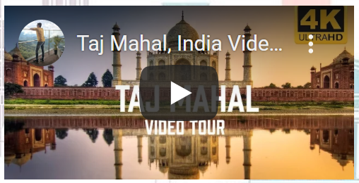

**Figure 7.** Embed YouTube Video

**2.Iframe tag to Embed Google Maps Location.**

<iframe src="<https://www.google.com/maps/embed?pb=!1m18!1m12!1m3!1d1805124.73700>

[24894!2d76.49555521016833!3d27.913195114688442!2m3!1f0!2f0!3f0!3m2!1i1024!2i768!4f13.1!3m3!1m2!1s0x39747121d702ff6d%3A0xdd2ae4803f767dde!2sTaj%20Mahal!5e0!3m2!1sen!2sin!4v1591280248639!5m2!1sen!2sin](https://www.google.com/maps/embed?pb=!1m18!1m12!1m3!1d1805124.73700)" frameborder="0" style="border:0;" allowfullscreen="" aria-hidden="false" tabindex="0"></iframe>

[23](https://www.google.com/maps/embed?pb=!1m18!1m12!1m3!1d1805124.73700)

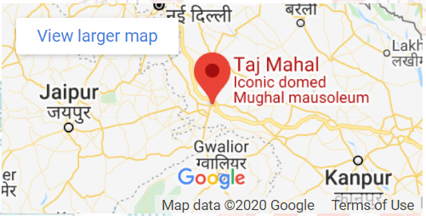**Figure 8.** Embed Google maps Location

22

**3.Iframe tag to Embed Google Maps 3D View.**

<iframe src="<https://www.google.com/maps/embed?pb=!4v1603620707685!6m8!1m7!1sCA>

[oSLEFGMVFpcFBWTHJPN1JyWC14UmFMNl9aN09Ud090RFdiaWpiZkRndDJodHUw!2m2!1d27.1748642!2d78.04139889999999!3f1.9099744355240489!4f0.6866649570257266!5f0.7820865974627469](https://www.google.com/maps/embed?pb=!4v1603620707685!6m8!1m7!1sCA)" frameborder="0" style="border:0;" allowfullscreen="" aria-hidden="false" tabindex="0"></iframe>

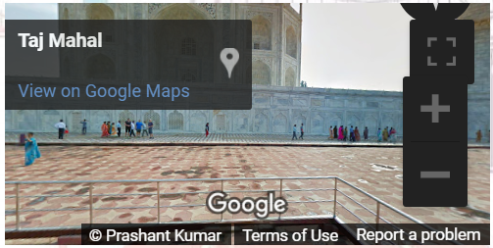

**Figure 9.** Embed Maps 3D View

**4.Code for Visitor Count.**

<img src="<https://www.webfreecounter.com/hit.php?id=gefqkxo&nd=6&style=121>" border="0" alt="visitor counter">

Using <https://www.webfreecounter.com/>



**Figure 10.** Visitor Count

**5.Code for Marquee Behavior.**

<marquee behavior="scroll" direction="left">This Site is Developed and Hosted by Rohit Kumar&nbsp;&nbsp;&nbsp;&nbsp;Thanks for Visiting&nbsp;&nbsp;&nbsp;&nbsp;Visit Again</marquee>

**Figure 11.** Marquee Behavior

**6.Code for Mail and Phone Behavior.**

<a href="<tel:9084950XXX>"><span class="glyphicon glyphicon-earphone"></span> 9084950XXX</a>

<a href = "[mailto: r.k296XXXX@gmail.com](mailto:%20r.k296XXXX@gmail.com)"><span class="glyphicon glyphicon-envelope"></span>

[r.k296XXXX@gmail.com</a](mailto:r.k296XXXX@gmail.com%3c/a)> **Figure 12.** Contact Link

**7.Code for Top Button.**

<button onclick="topFunction()" id="myBtn" title="Go to top">^</button>

23

<script>

var mybutton = document.getElementById("myBtn");

window.onscroll = function() {scrollFunction()};

function scrollFunction() {

if (document.body.scrollTop > 20 || document.documentElement.scrollTop > 20) {

mybutton.style.display = "block";

}

else {

mybutton.style.display = "none";

}

}

function topFunction() {

document.body.scrollTop = 0;

document.documentElement.scrollTop = 0;

}

</script>

**8.Code for Image Slideshow.**

<! –– IMAGE SLIDESHOW ––>

<div class="slideshow-container">

<div class="mySlides fade">

<div class="numbertext">1 / 10</div>

<img src="1.tajmahal/image1.jpg" style="width:100%">

</div>

<div class="mySlides fade">

<div class="numbertext">2 / 10</div>

<img src="2.redfort/image1.jpg" style="width:100%">

</div>

<div class="mySlides fade">

<div class="numbertext">3 / 10</div>

<img src="3.lotustemple/image1.jpg" style="width:100%">

</div>

<div class="mySlides fade">

<div class="numbertext">4 / 10</div>

<img src="4.qutubminar/image1.jpg" style="width:100%">

</div>

<div class="mySlides fade">

<div class="numbertext">5 / 10</div>

<img src="5.victoriamemorial/image1.jpg" style="width:100%">

</div>

<div class="mySlides fade">

<div class="numbertext">6 / 10</div>

<img src="6.gatewayofindia/image1.jpg" style="width:100%">

</div>

<div class="mySlides fade">

<div class="numbertext">7 / 10</div>

<img src="7.charminar/image1.jpg" style="width:100%">

</div>

<div class="mySlides fade">

<div class="numbertext">8 / 10</div>

24

<img src="8.hawamahal/image1.jpg" style="width:100%">

</div>

<div class="mySlides fade">

<div class="numbertext">9 / 10</div>

<img src="9.mysorepalace/image1.jpg" style="width:100%">

</div>

<div class="mySlides fade">

<div class="numbertext">10 / 10</div>

<img src="10.cst/image1.jpg" style="width:100%">

</div>

</div><br>

<div style="text-align:center">

<span class="dot"></span> <span class="dot"></span> <span class="dot"></span><span class="dot"></span>

<span class="dot"></span> <span class="dot"></span><span class="dot"></span> <span class="dot"></span>

<span class="dot"></span><span class="dot"></span>

</div>

<script>

var slideIndex = 0;

showSlides();

function showSlides() {

var i;

var slides = document.getElementsByClassName("mySlides");

var dots = document.getElementsByClassName("dot");

for (i = 0; i < slides.length; i++) {

slides[i].style.display = "none";

}

slideIndex++;

if (slideIndex > slides.length) {slideIndex = 1}

for (i = 0; i < dots.length; i++) {

dots[i].className = dots[i].className.replace(" active", "");

}

slides[slideIndex-1].style.display = "block";

dots[slideIndex-1].className += " active";

setTimeout(showSlides, 1000);

}

</script>

25

**CHAPTER 4 - SNAPSHOTS**

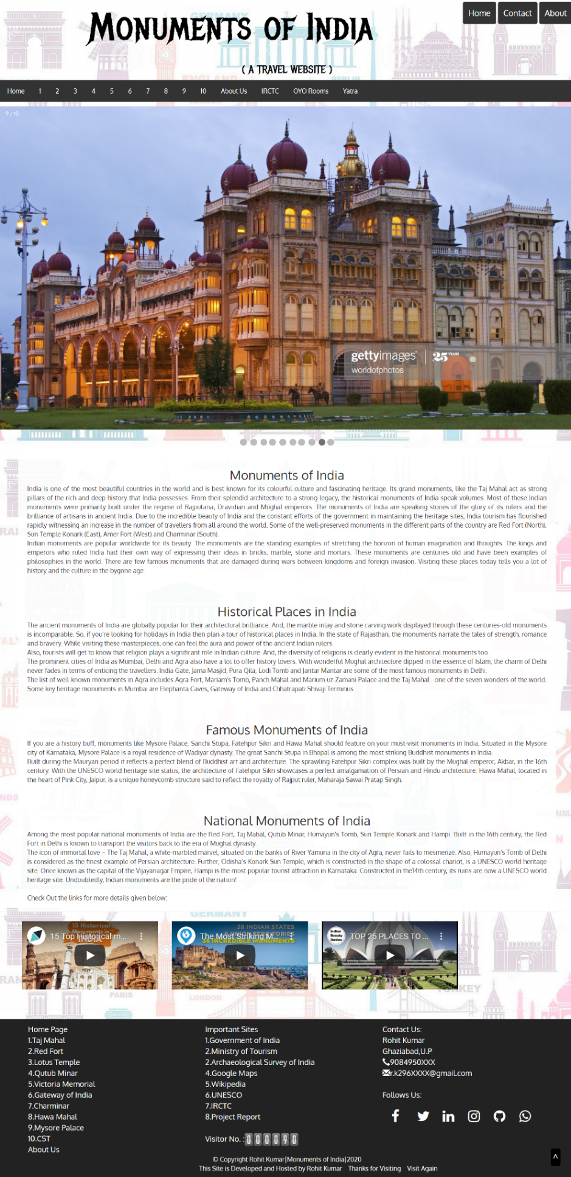1.Monuments of India (monuments.html)

**Figure 13.** Output for Monuments of India (monuments.html)

2.TajMahal (tajmahal.html)

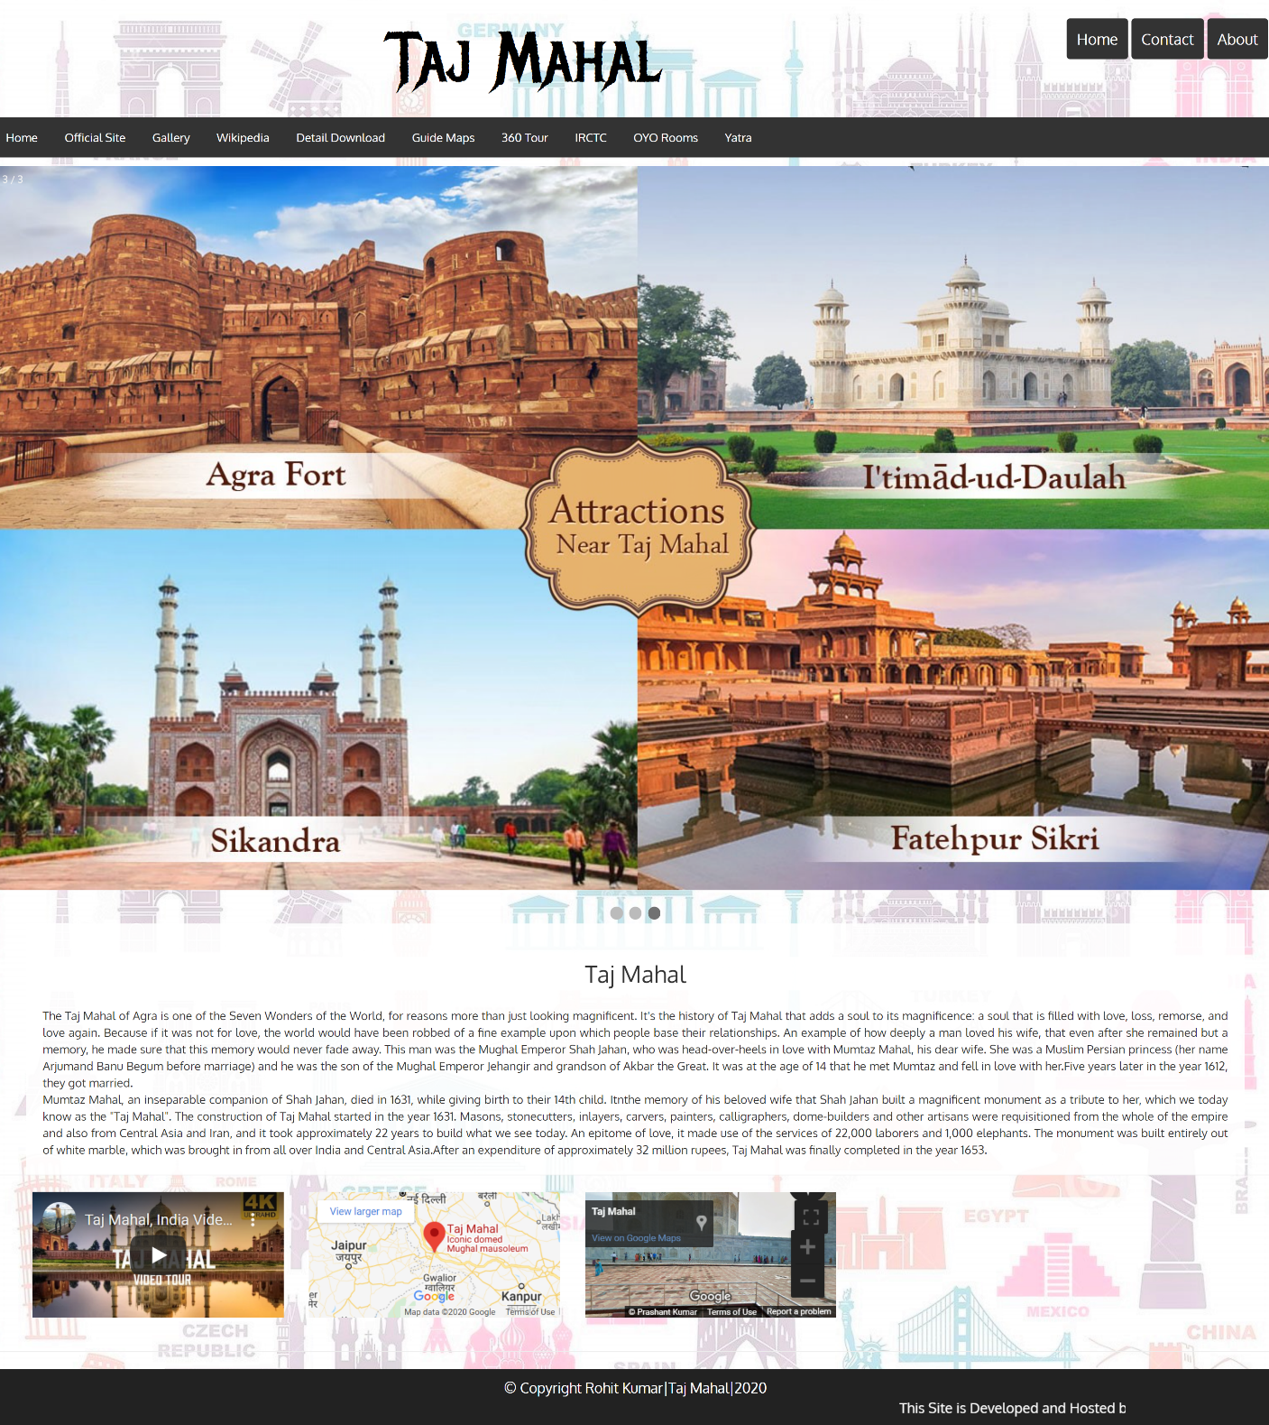

**Figure 14.** Output for Taj Mahal (tajmahal.html)

27

3.Red Fort (redfort.html)

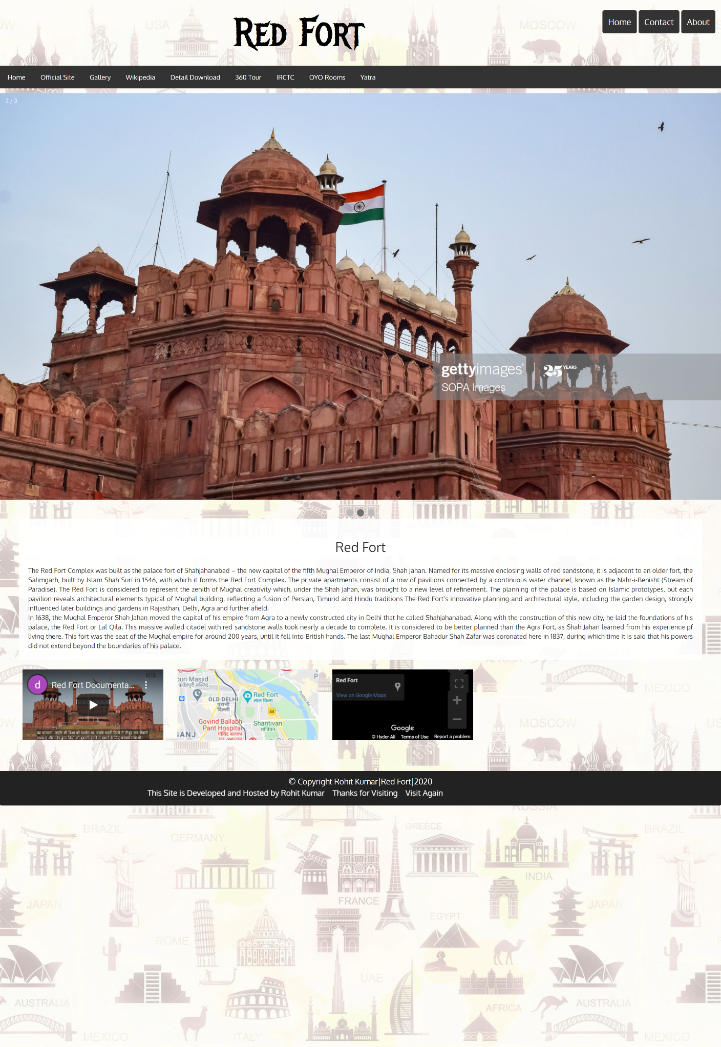

**Figure 15.** Output for Red Fort (redfort.html)

28

4.Lotus Temple (lotustemple.html)

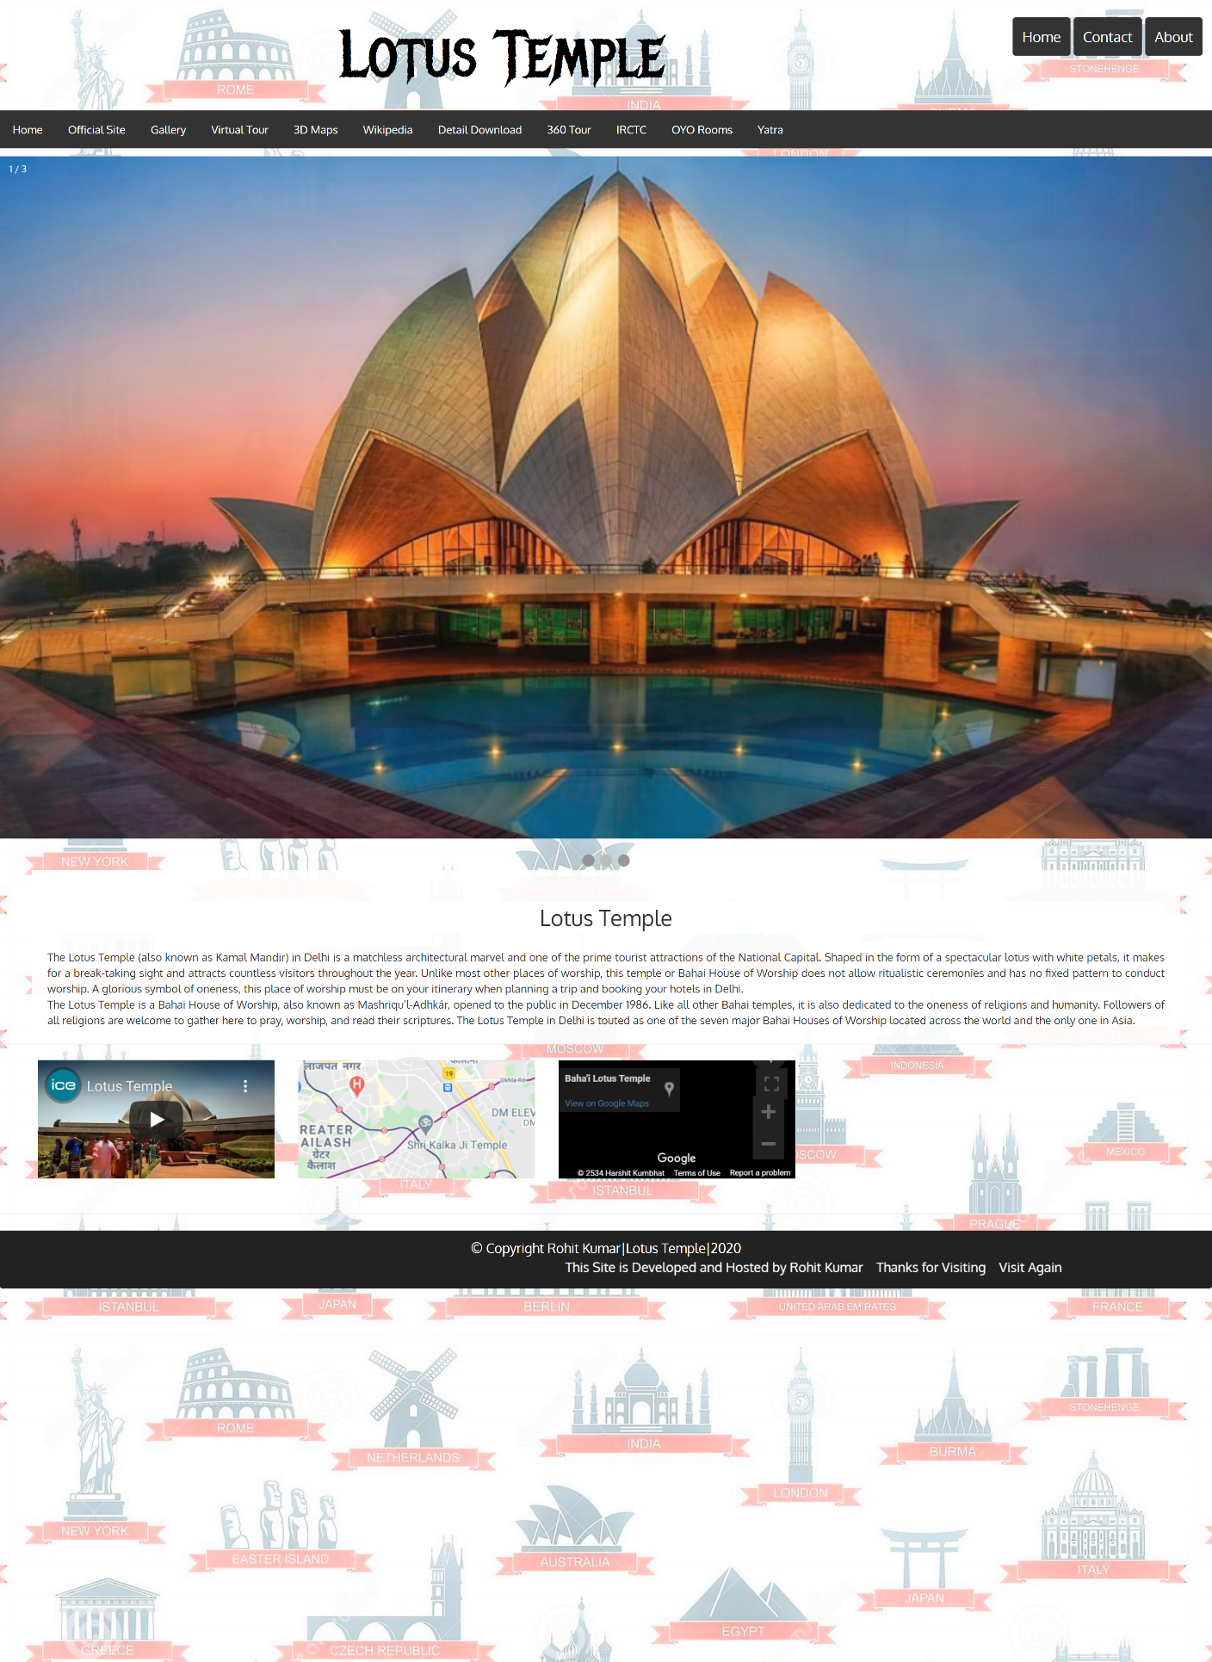

**Figure 16.** Output for Lotus Temple (lotustemple.html)

29

5.Qutub Minar (qutubminar.html)

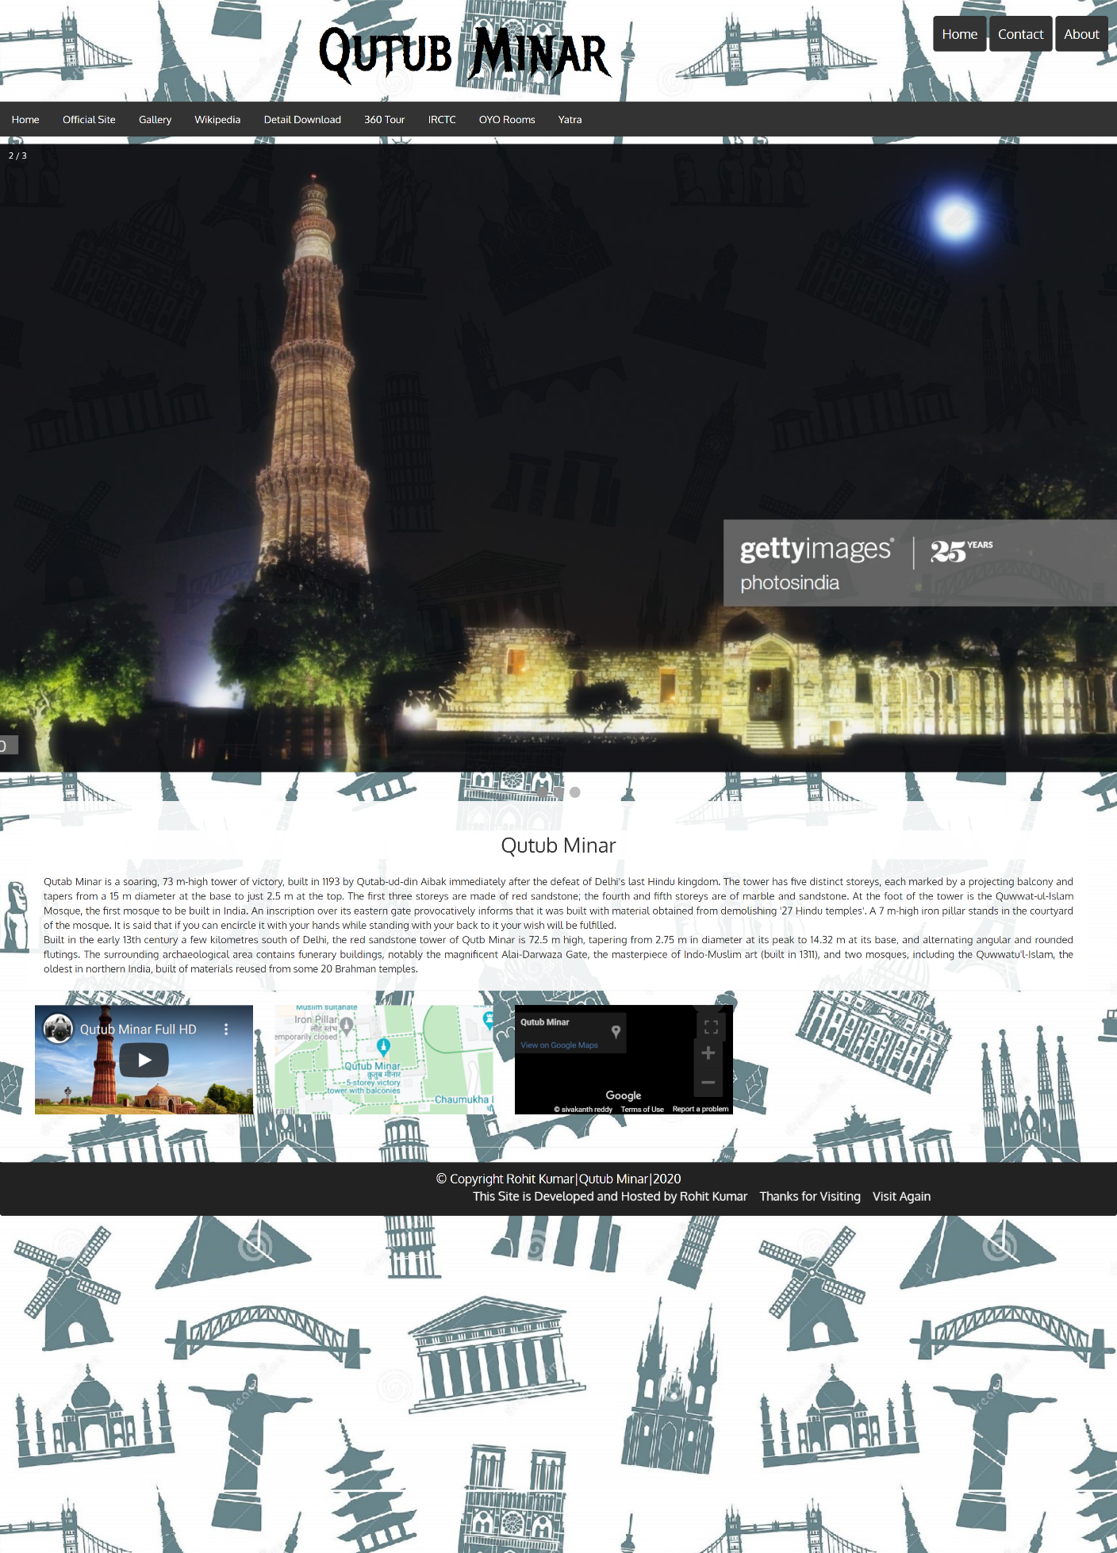

**Figure 17.** Output for Qutub Minar (qutubminar.html)

30

6. About Us (about.html)

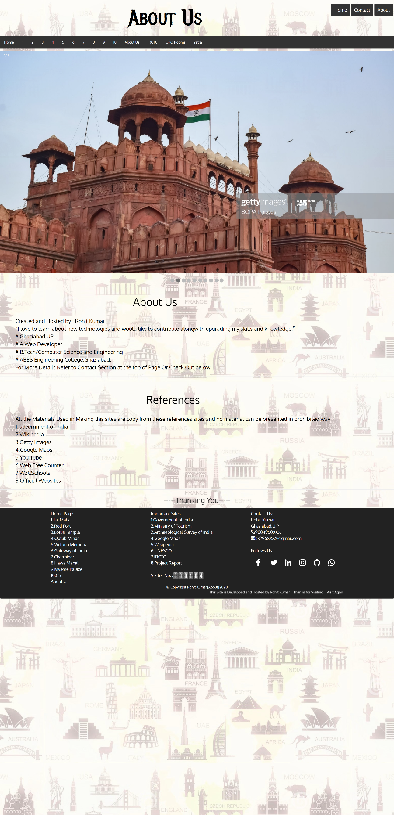

31

**Figure 18.** Output for About Us (about.html)

31

**CHAPTER 5 - RESULTS AND DISCUSSIONS**

This Projects results out in a Front-End Website whose Snapshots are given above.

The data are taken from the Various Websites.

The Proper URL of the Website is <https://rk-rohitkumar.github.io/monuments/monuments.html>

And this Link is shorten using Rebrand (<https://www.rebrandly.com/>) to <https://rebrand.ly/monumentsofindia>.

This website is hosted over to the GitHub Server. GitHub Pages is the Service through which we can host our Website to the world free of Cost.

It is a HTTPS website whose SSL Certificates are provided by **DigiCert SHA2 High Assurance Server CA.**



**Figure 19.** Image of Website SSL Certificate – General

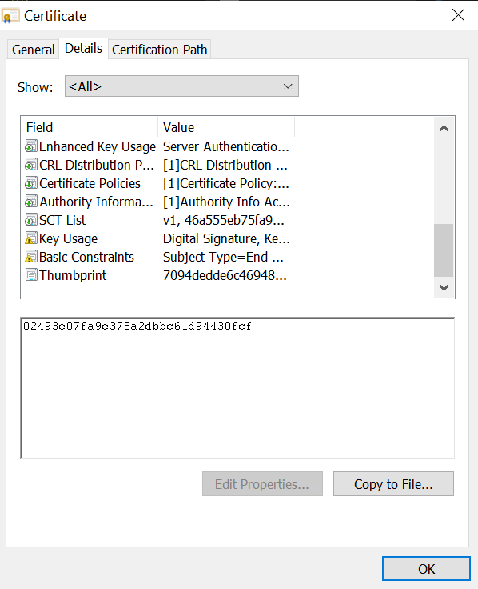

**Figure 20.** Image of Website SSL Certificate – Details



**Figure 21.** Image of Website SSL Certificate – Certification Path

33

**Cookies** use in the websites are from:

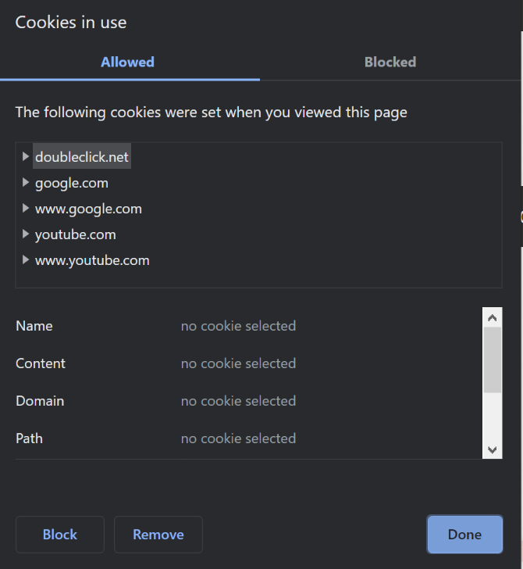

**Figure 22.** Cookies Used by Website

Permission required to View Website

* Sound
* Image
* Flash
* Automatic Download
* JavaScript

34

**CHAPTER 6 - CONCLUSIONS AND FUTURE SCOPE**

This Website helps in providing information about various monuments of India.

This Methodology of this website is:

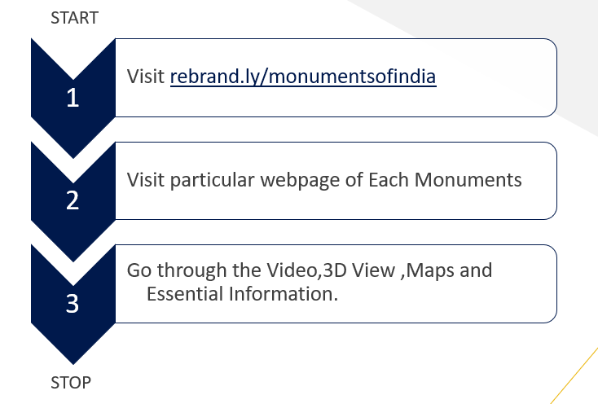

**Figure 23.** Methodology Used

**Future Scope:**

These Website is further Extended to high level if I have time and all the Sources in these ways

**Main Scope :**

* Providing Traveling Distance to the Visitors from their homes.
* Providing E-Prospectus about these Monuments

**Other Possible Scopes :**

* E – Ticketing System to book visiting Tickets.
* Providing Taxi at these Places.
* Opening Travel Agency.
* To book Railway/Airplane Tickets through IRCTC.

**REFERENCES**

* W3Schools: <https://www.w3schools.com/>
* HTML, CSS & JavaScript (Coursera): <https://www.coursera.org/>
* Getty Images: <https://www.gettyimages.in/>
* Google Maps: <https://www.google.co.in/maps>
* Google YouTube: <https://www.youtube.com/>
* Yatra: <https://www.yatra.com/>
* Lestari, D., Hardianto, D., Hietayanto, A.,(2014), “Analysis of User Experience Quality on Responsive Web Design from its Informative Perspective”, International Journal of Software Engineering and its Applications,(5),53-62.

URL:

<https://www.researchgate.net/publication/268808298_Analysis_of_User_Experience_Quality_on_Responsive_Web_Design_from_its_Informative_Perspective>

* Kumar, S Praveen. (2014). “Monuments for the Development of Tourism.” 1. 87-94.

URL: [<https://www.researchgate.net/publication/331872308_Monuments_for_the_Development_of_Tourism>](https://www.researchgate.net/publication/331872308_Monuments_for_the_Development_of_Tourism)

* Navratil, J., Picha, K., Hrebcova,J. (2010), “The Importance of Historical Monuments for Domestic Tourists: The case of South-Western Bohemia (Czech Republic).” Moravian Geographical Reports. 18. 45-61.

URL:

[<https://www.researchgate.net/publication/283509215_The_Importance_of_Historical_Monuments_for_Domestic_Tourists_The_case_of_South-Western_Bohemia_Czech_Republic>](https://www.researchgate.net/publication/283509215_The_Importance_of_Historical_Monuments_for_Domestic_Tourists_The_case_of_South-Western_Bohemia_Czech_Republic)